# Sentimental Analysis

INTRODUCTION:

This analysis is about to know the reviews of the products which sold to the people, through this we can build a system to know the products well before people use it. We are using to make this type of system “MACHINE LEARNING”.

APPROCH:

For making this system in easy way, we[team] are using the many of predefine dataset. For make this data readable form we use the python notebook. When we start to analysis the data we need to do some work on it like add some extra rows and column.

For sentimental analysis we are using linear classifier which is test our train data. Linear regression is best for this sentimental analysis because we know that after sold a product people give the reviews about that product, review may in negative way or may be in positive way so we can easily make the difference.

TOOL BOX

Anaconda navigator

“ipynb”

Libraries

Graphlab.SFrame

Dataset

Amazone.baby.gl/zip

Project Guider: Asst. Prof. Diksha goyal (ma’am)

Project Creators: Hritik kumar sharma(leading) and others.

Code explanation:

As we usually do import the graphlab after this import the dataset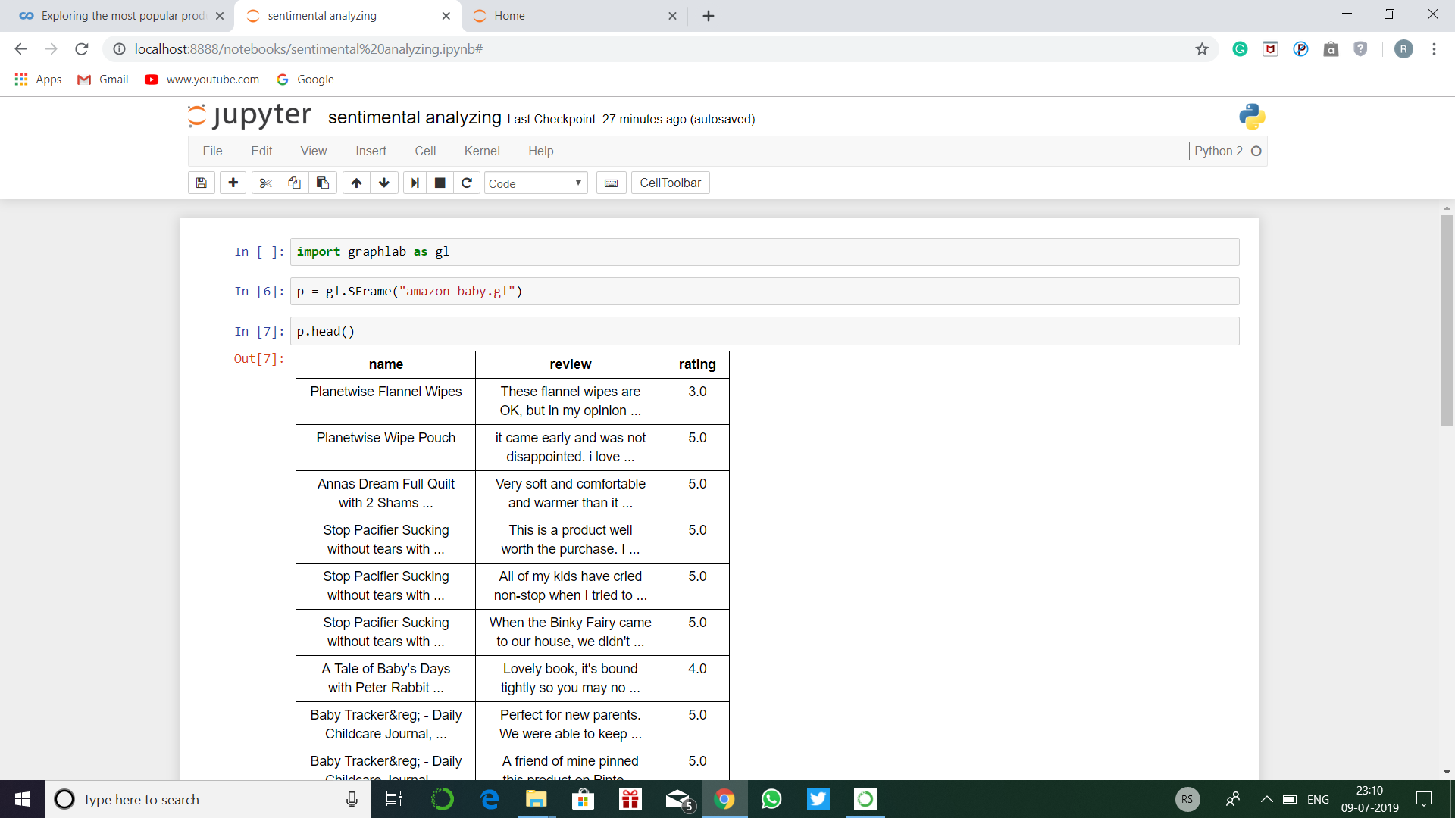

After this we need to add a column to count the word for each product reviews

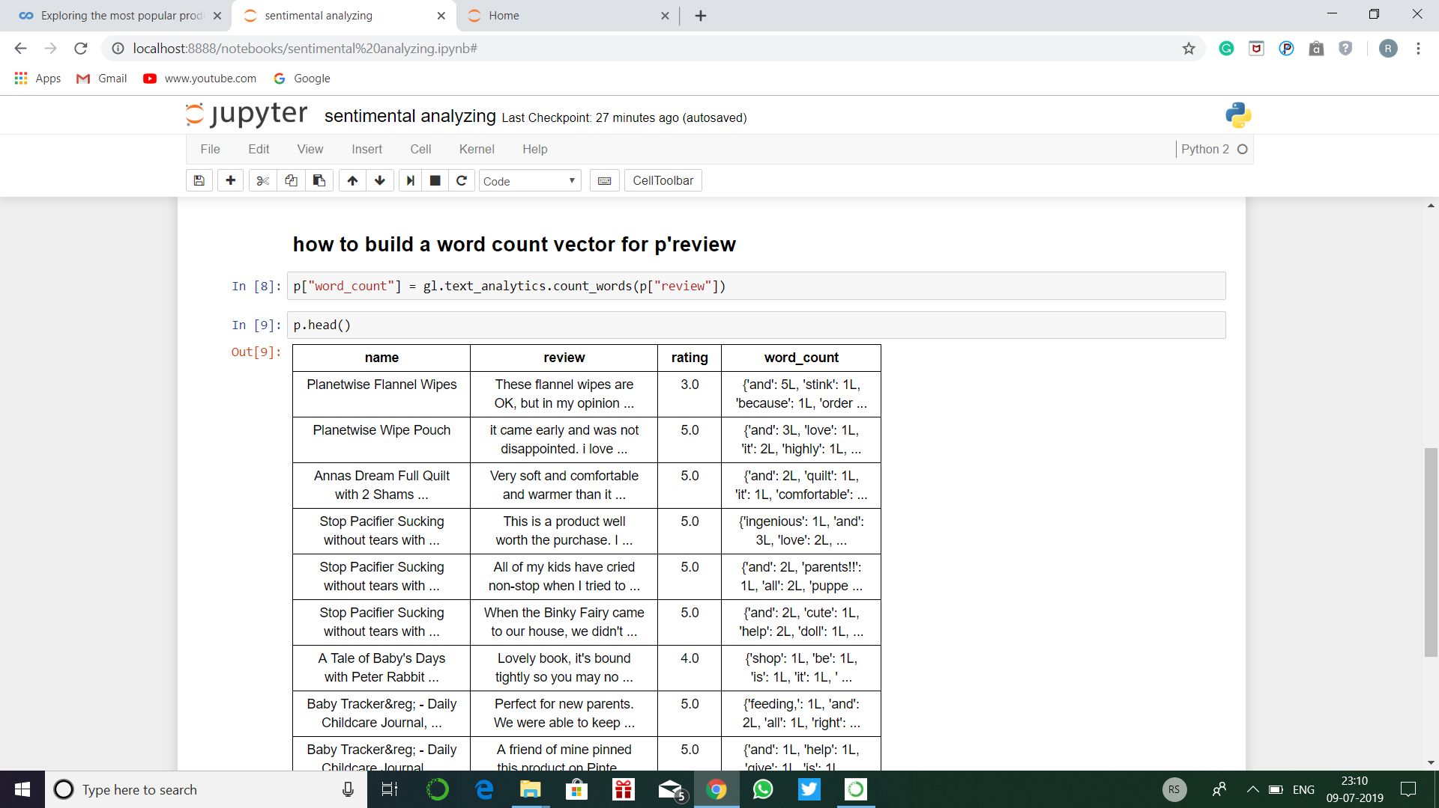

Through the word count column we can get the a idea to know the review was positive or negative.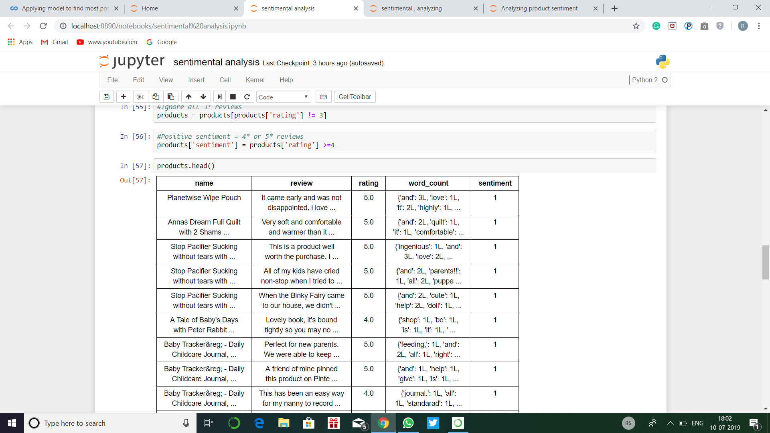

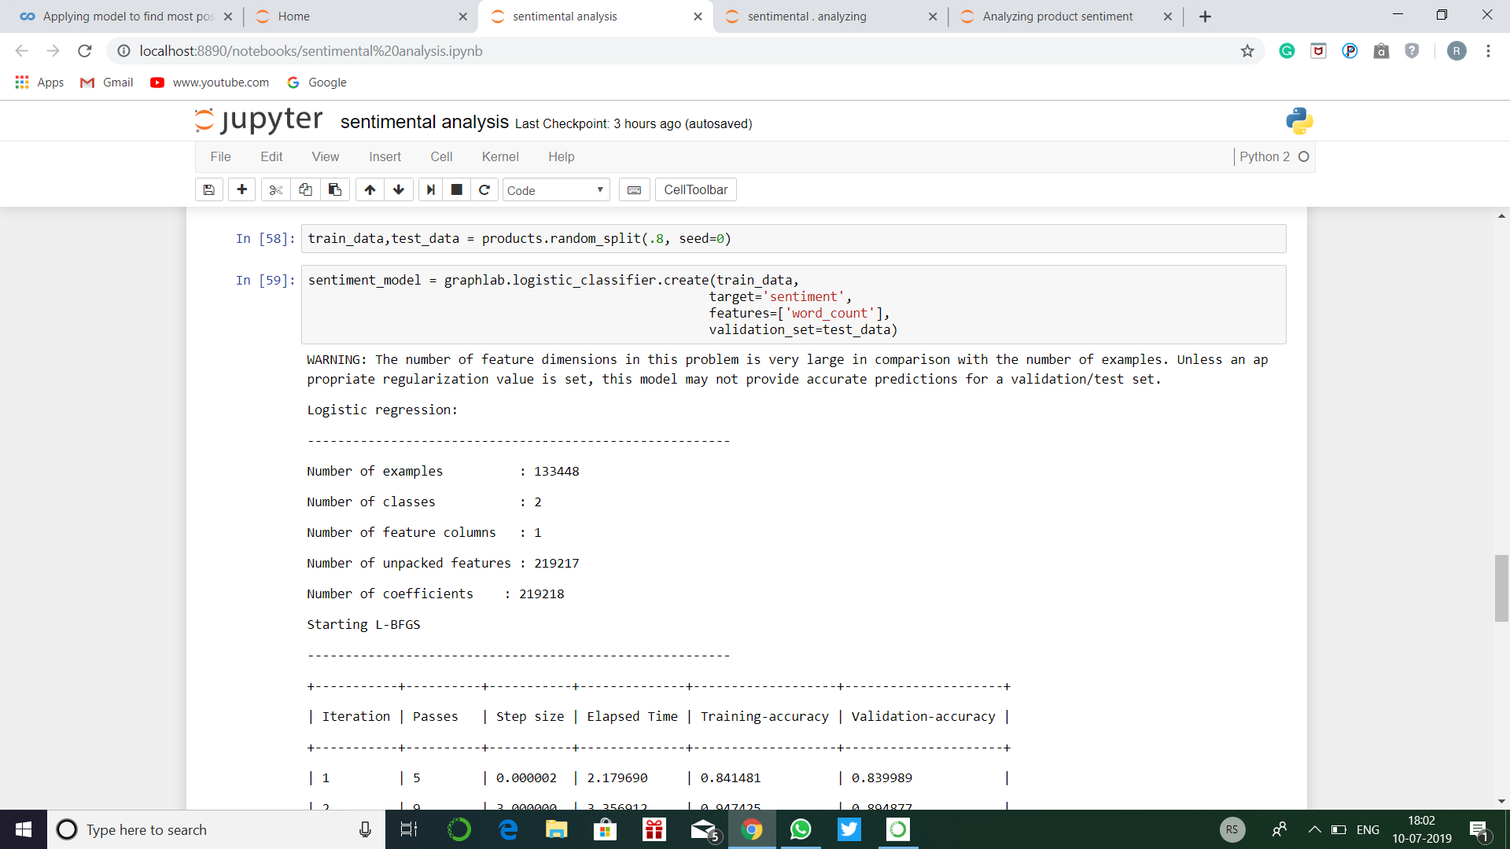

This is how the linear classifier work. if we want to it in visualization form we can get it by canvas.

Experience

This week is brings me unexpected things like how can we build a system of reviews to make people right decision they should buy it or not by see their reviews.

Report by RITIK SONI